

MAXIMISE

INSTALLATION GUIDE

Prepared by Maximise| 28th Oct 2022

@Copyright 2022 Version 1 – All Rights Reserved

**Table of Contents**

1 Introduction 3

1.1 Purpose 3

2 Database Implementation 4

2.1 DBA Prerequisite Tasks 4

2.2 Assumptions 5

3 Maximise Code Installation 6

3.1 STEP 1: Prepare 6

3.2 STEP 2: Installation 9

3.3 STEP 3: OIC 12

3.4 STEP 4: VBCS 17

3.5 STEP 5: Validation Reports 20

**Version Control**

|  |  |  |  |
| --- | --- | --- | --- |
| Date | Version | Changed By | Reason for Change |
| 21-Jul-2021 | 1.0 | Lokesh Shanbhag | No previous version. |
| 13-Jan-2022 | 2.0 | Pallavi Kanajar | Updated Installation document for OIC installation |
| 28-Feb-2022 | 3.0 | Joe Lalor | Installer Updates |
| 29-Mar-2022 | 4.0 | Praveen Nair | Install Doc Formatting and Release Update for 22.1 |
| 31-May-2022 | 4.1 | Joe Lalor | Automatic validity check |
| 28-Oct-2022 | 4.2 | Praveen Nair | Added Note 2 and update DB pre-requisite |
| 31-Oct-2022 | 4.3 | Shaik Latheef | Added Assumptions |
| 29-Dec-2023 | 4.4 | Shaik Latheef | Added Validation Reports and updated integration and connections lists |

Circulation List

|  |  |
| --- | --- |
| Name | Organisation/Title |
| Ken MacMahon | Version 1 |
| Praveen Nair | Version 1 |
| Pallavi Kanajar | Version 1 |
| V1 Cloud Practice | Version 1 |

Glossary

The following terminology and abbreviations are used throughout this document:

|  |  |
| --- | --- |
| Term | Description |
| EBS | Oracle e-Business Suite (general term) |
| OS | Operating System |
| OU | Operating Unit – A Business Structure Entity to which specific data can be associated. |
| R11i | Oracle e‑Business Suite R11i |
| Maximise | Version 1’s Cloud Data Migration accelerator framework. |
| R12 | Oracle e‑Business Suite R12 |
| TBC | To Be Confirmed |
| TBD | To Be Determined |
| DBAAS | Database As a Service |
| DBA | Database Administrator |
| TNS | Transparent Network Substrate |

# Introduction

## Purpose

The purpose of the installation document is to provide a reference at any time for the Implementation team working on a Maximise Installation. This document describes the key requirements of Database configuration and assumptions which should be taken into consideration before installing Maximise Data Migration components. The document also covers the installation sequence with detailed steps described in Section 3.

On a practical level, the requirements will have a continuing influence on the scope and content of the architecture design work throughout the project life; therefore, it is important that the list is as complete as possible and agreed early during the Elaboration Phase of the project. The architecture team will need to keep these requirements in mind throughout the project and help create an architecture that is compatible with the Maximise requirements. Furthermore, if the architecture requirements alter mid-project, the changes should be noted and disseminated in a timely manner.

This document should be distributed to all Implementation team members who will be responsible for deploying Maximise code installation in Client’s database environment. Subsequent changes to the architecture scope will be communicated universally before implementation of these changes begins.

The project manager can use this document to understand how the delivery team plans to conduct Maximise installation and communicate required Database requirements as well as assumptions to the client.

The installation process allows customisation by the delivery team. This may fulfil a particular client’s requirements. If the delivery includes a customisation which may benefit delivery for other clients, please communicate this to the development team.

|  |
| --- |
| **Note 1**: As the installation will drop and re-create objects, it is recommended that a backup of all required objects is taken before the installation (especially on instances where Maximise DM is being re-installed)  **Note 2**: If a project does not require Maximise, it is advised that the relevant instance(s) are terminated to keep the cost down |

# Database Implementation

This section outlines the Database requirements and associated steps for the DBA to install Maximise. It also highlights assumptions which would be taken under consideration before installing Maximise on Standalone database.

## DBA Prerequisite Tasks

* Create standalone Database (Cloud DBAAS) with the configuration outlined below:

|  |  |
| --- | --- |
| Database parameters | Descriptions |
| DB Type | Standalone DB |
| Shape | VM. Standard2.1 or higher |
| OCPU Count | Minimum 1 |
| Network Bandwidth | 1 GBPS |
| Memory | 15 GB |
| Local Disk | Block Storage Only |
| Capacity type | 500 GB Free Storage with On-demand configuration |
| Database System Version | 19.16.0.0.0 Standard Edition or higher |
| Character Set,  National Character Set | AL32UTF8, AL16UTF16 |
| Database Workload | OLTP |
| Pluggable Database Name | MXDM_PDB1 |

* The installation is performed as the *opc* user on the standalone database host, so *opc* logon credentials are required.
* The installation creates database infrastructure by sudoing to the *oracle* user and executing scripts in the opc folder tree. SQLPlus activity is logged to text files in the opc folder tree. Therefore, the *oracle* user requires **Read** and **Execute** permissions on the opc folder during the installation. One way to achieve this is to set Others permissions as follows:

* If migrating from an EBS legacy system, the installation will connect the standalone database to the source EBS database via a Database Link. Therefore, the client network configuration must allow this.
* The SYS password for the Standalone database is required during installation.
* The installation assumes the schema name on the legacy EBS database is *apps*.
* The Oracle connection string (TNS entry), e.g., (DESCRIPTION=(ADDRESS_LIST=(ADDRESS=(PROTOCOL=TCP)(HOST=xx.xx.xx.xx)(PORT=xxxx)))(CONNECT_DATA=(SERVICE_NAME=xxxx))) is required to create the database link for migration from a legacy database.

**Note:** replace the highlighted above with details of the Maximise database

* If re-installing, appropriate backup of database objects including configuration data in tables should be taken

## Assumptions

* The Client’s I.T Department or Version 1 delivery team will be responsible for the database configuration

where Maximise Tool will be installed.

* Only one Maximise DB instance should be provided for the tool installation.
* Only one OIC environment should be provided for the tool’s integration setup.
* Only one VBCS environment should be provided to host the application.
* If more than one DB instance or OIC environment is provisioned, then it is the implementation team’s responsibility to export the Maximise Code from one environment to another and install the tool.
* All configuration items e.g., Organisation, location, job, grade, talent, position etc are the responsibility of the implementation team.

# Maximise Code Installation

## STEP 1: Prepare

| Seq. | Installation Action | Step Complete | Comments / Notes |
| --- | --- | --- | --- |
|  |  |  |  |
| 1. | Download the latest version of Maximise DM from the following location in Gitlab:  [Innovation / Maximise / Data Migration / Maximise DM Release · GitLab (version1.com)](https://gitlab.version1.com/innovation/maximise/data-migration/maximise-dm-production-release) |  | Download the Folder Install in the path |
| 2. | Login to the standalone database as an *opc* user |  | Use SSH key to login to the standalone database server |
| 3. | Navigate to opc home directory.  cd /home/opc/ |  | Use **pwd** command to find current path in Linux. |
| 4. | Unzip the downloaded file from Bitbucket and transfer the files across to the home directory on the server. Transfer the files in ASCII mode     |  |  |
| 5. | The installation logs its progress to .log files in the install folder, so this folder should allow write access to the Oracle user:   |  | chmod -R 777 Install |
| 6. | Convert all sh script Files to Dos2 unix |  | *cat xxmx_master_mxdm.sh | tr -d '\015' > master_mxdm.sh*  *mv master_mxdm.sh xxmx_master_mxdm.sh*  *chmod 777 xxmx_master_mxdm.sh*  *cat xxmx_custom.sh | tr -d '\015' > custom.sh*  *mv custom.sh xxmx_custom.sh*  *chmod 777 xxmx_custom.sh* |
| 7. | Ensure that the xxmx_master_mxdm.sh is available and has execute permissions. |  |  |
| 8. | This step applies if Maximise is being installed on an instance where a previous release of Maximise was deployed and the project team has updated/customised the packages provided previously to meet customer requirements. As a re-install of Maximise will drop objects and re-create database objects (including packages), if the project team prefers to re-apply their backup package changes, the installation may be customised via the shell script ***xxmx_custom.sh*** in the Install folder. The script contains a call to xxmx_custom.sql as an example of suggested use. |  | For **R11 EBS Client**, the R11 package changes can be deployed in this manner. R11 specific scripts will be under the **R11** sub-folder |

### 

## STEP 2: Installation

| Seq. | Installation Action | Step Complete | Comments / Notes |
| --- | --- | --- | --- |
|  |  |  |  |
| 1. | On the server, navigate to the Maximise install directory:  *cd $HOME/Install*  *(assuming the zip file was extracted under $HOME)* |  |  |
| 2. | Execute the install script:  *./xxmx_master_mxdm.sh* |  | Ensure the shell script is converted to Dos2unix format using step 6 ( section 3.1) |
| 3. | Detailed logs are written to the Install directory during installation. Use these if the installation is not successful or to verify the installation. |  |  |
| 4. | Create XXMX schemas (Y/N)? (Y)  **Note: This process takes between 2 to 3 minutes** |  | The default is Y to create or re-create the full DB infrastructure |
| 5. | Enter the SYS password for MXDM_PDB1 |  | Provided by DBA |
| 6. | Maximise uses 3 schemas – STG, XFM and CORE – for its infrastructure. Choose a password for the STG schema |  | The maximise schema passwords must consist of at least 9 characters, 2 numerals, 2 uppercase, 2 lowercase and 2 special chars (no quote marks or Hash) |
| 7. | Choose XFM SCHEMA password  Choose CORE SCHEMA password |  | XFM and CORE passwords will default to the STG password if left blank |
| 8. | Create DB link to EBS database (Y/N)? (Y) |  | Default is Y |
| 9. | Enter the APPS password for EBS database |  | The legacy EBS schema name is assumed to be APPS |
| 10. | Enter the EBS database connection string  e.g.:  (DESCRIPTION=(ADDRESS_LIST=(ADDRESS=(PROTOCOL=TCP)(HOST=xx.xx.xx.xx)(PORT=xxxx)))(CONNECT_DATA=(SERVICE_NAME=xxxx))) |  | Replace the high-lighted with the details of legacy EBS database. |
| 11. | Select Install XXMX_CORE (Y/N)? Y |  | To Install all Core Objects.  If any object fails with DBlink Issue for NonEBS Client – Ignore the error. |
| 11. | Which EBS modules will be migrated?  FIN (Y/N)? (Y)  HCM (Y/N)? (Y)  IREC (Y/N)? (Y)  PAY (Y/N)? (Y)  Maximise Custom Extensions and Core OIC Objects (Y/N)? (Y) |  | FIN = Financials  HCM = Human Capital Management  IREC = HCM Recruitment.  PAY = Payroll  Y is the default |
| 12. | The installer checks for invalid objects at the end of the install process. The sys password is required for this step.  Invalid objects are listed as follows:  Invalid VIEW XXMX_CORE XXMX_HR_HCM_TAL_PRF_V  Invalid PACKAGE XXMX_CORE XXMX_HDL_UTILITIES _PKG  Invalid PACKAGE BODY XXMX_CORE XXMX_HDL_UTILITIES_PKG  Review the log files for more information about invalid objects.  If there are no invalid objects, the installation is deemed a success and this message appears:  Maximise 2.0 successfully installed |  |  |
| 13. | Connect to Database and check for failed objects. If any scripts failed to execute or errors. Please run the scripts manually in SQLDEVELOPER in Schema XXMX_CORE. |  | **Check for Failures** |
| 14. | Populate the table XXMX_CORE_PARAMETERS with below values for  **NONEBS Client:**  INSERT INTO XXMX_CORE_PARAMETERS VALUES  (1,‘STG_POPULATION_METHOD‘,‘STG_POPULATION_METHODS‘,‘DB_LINK’,’Y’);  **EBS Client:**  INSERT INTO XXMX_CORE_PARAMETERS VALUES  (1,‘STG_POPULATION_METHOD‘,‘STG_POPULATION_METHODS‘,‘DATA_FILE’,’Y’); |  |  |
| 15. | Populate the table **xxmx_hcm_datafile_xfm_map** using the excel **xxmx_hcm_datafile_xfm_map.xlsx** in Folder INTERNAL_EXCEL  Populate the table xxmx_dm_ess_job_definitions using the excel **xxmx_dm_ess_job_definitions.xlsx** in Folder INTERNAL_EXCEL |  |  |

## STEP 3: OIC

The following section details the steps required to import the integration package for Maximise OIC.

### Pre-requisites

* Maximise installation is complete and Core Objects are installed
* Ensure Admin Access to Oracle Integration Cloud is given to the OIC user.
* Downloaded the latest version of the **maximise.dm.par** and **MaximiseDashboard.par** packages from GitLab (these files should be under the **Install/OIC** folder) for OIC installation.
* Ensure File Server and Visual Builder are enabled in OIC as below. Graphical user interface, text, application

  Description automatically generated

### Import Integration Packages

To import the OIC Integration Packages:

1. Log on to OIC
2. Click on **Packages**

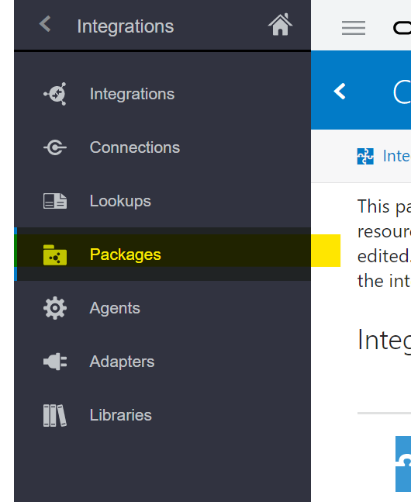

1. Click on the **Import** button

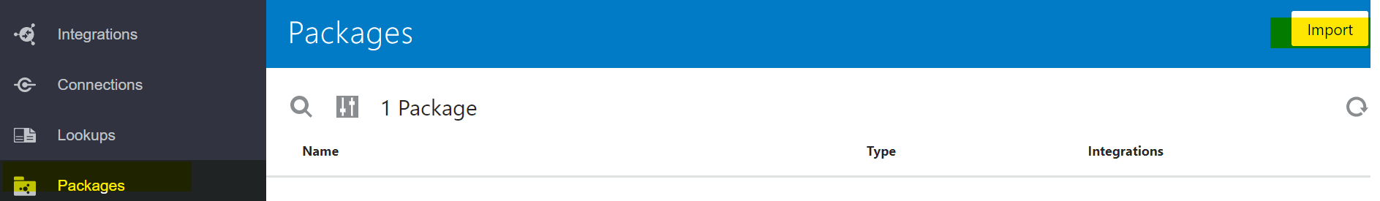

1. Click **Browse** to open a navigation pane
2. Select the integration package archive (.par) file to import

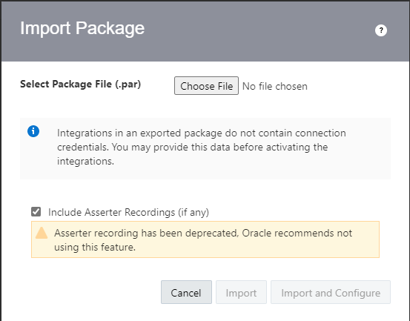

1. Click **Import**. The packages are added to the **Packages** list

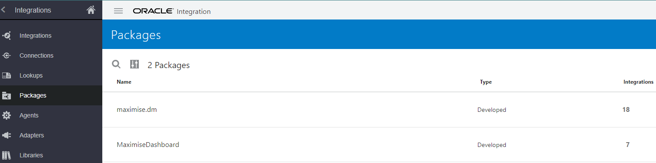

1. The **maximise.dm** package should import the following integrations
   * INTDM999001 Data Migration Run Extract Transform
   * INTDM999002 DM Extract File Generation
   * INTDM999003 DM Transform File Generation
   * INTDM999004 Data Migration Load File Generation
   * INTDM999005 Data Migration Mapping Process
   * INTDM999006 Load FBDI to Interface Table
   * INTDM999007 DM Run Fusion Import Process
   * INTDM999008 File Archive Process
   * INTDM999009 Update XFM Data Dictionary
   * INTDM999011 Update FA Book Ledger
   * INTDM999012 Update GL Access Set
   * INTDM999013 Validate Account Code Combinations
   * INTDM999014 Child Code Combinations
   * INTDM999015 DM Write Load File to DB Server
   * INTDM999016 Move File To WinScp
   * INTDM999017 Moves Load File from DB Server to FTP
   * Metadata CRUD - Get
   * Update Migration Metadata
2. The **MaximiseDashboard** package should import the following integrations.
   * INTDB555004 Display Import Error and success count
   * INTDB555006 Integration to get Report Count
   * INTDB555007 Schedule Import Error and Success Rpt
   * INTDB999001 Ext Trnsfrm Count for Dashboard
   * INTDB999002 Control Table Details for Dashboard
   * INTDB999003 Get Fusion Error Count and Details
   * INTDB999005 Import Count and Report

### Configure Connections

For the integration to be successful, edit the Connections as required. The connections can be edited from the Packages section as below:

1. Under Packages, click on the **Configure** icon to show a list of Integrations, Connections and Lookups for the package

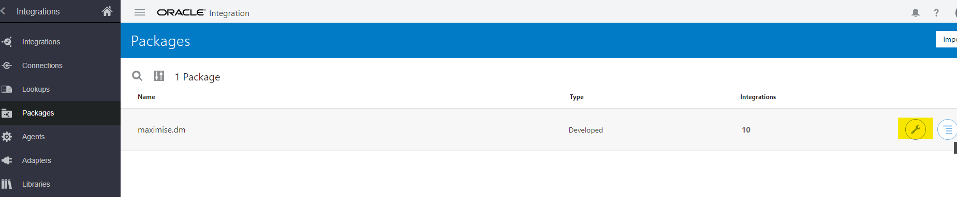

1. Click on the **Connections** link to navigate to the available connections

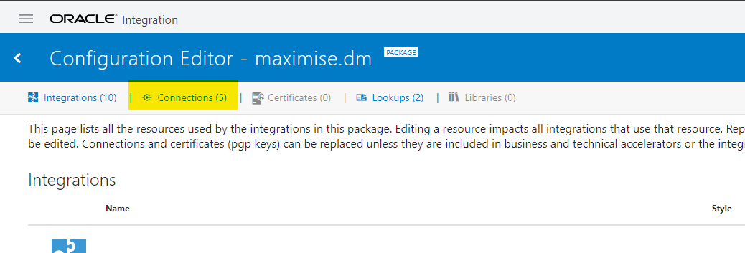

1. Under Connections, all available connections should be displayed.

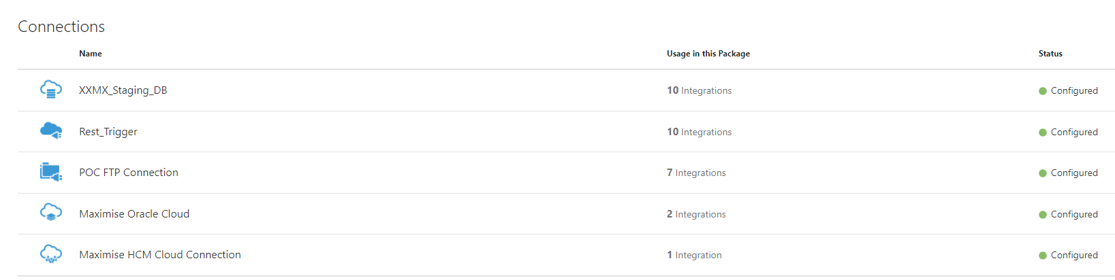

1. To edit the connections, hover the mouse pointer on the connection row to display the **Edit** and **Replace** options

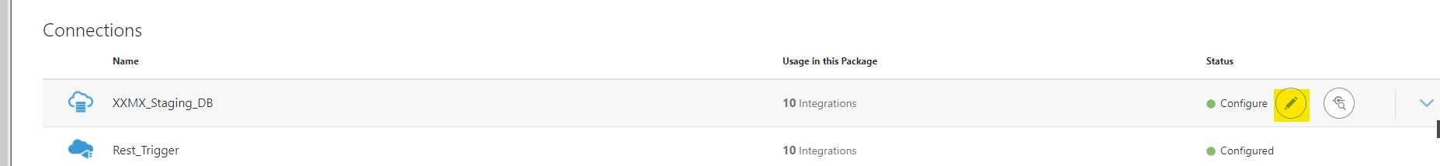

1. Click on **Edit** to edit the connection to change the connection properties, username, password, etc.
2. **Save** and **Test** the configuration after making the changes.
3. The following connections should be configured to support the integrations.
   * XXMX_SAAS_BIP_REP_SERV
   * XXMX_DB_FILESERVER
   * Invoke BIP Report for Dashboard
   * Cloudbridge HCM Cloud Connection
   * Cloudbridge Oracle Cloud Connection
   * XXMX_OIC_FTP_CONN
   * Rest_Trigger
   * XXMX_SAAS_GL_CVR_CONN

### Integrations

#### Activate Integrations

On importing the package, the integrations will be imported and should be set as Active. If the status is not active, follow the steps below to activate an integration:

1. Navigate to available Integrations under the Packages > Configuration Editor > Integrations.

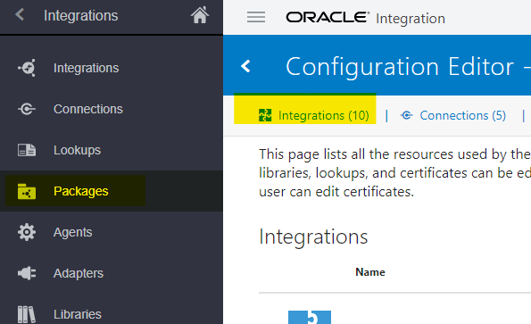

1. Click on the Activate icon to activate Integration (see example below)

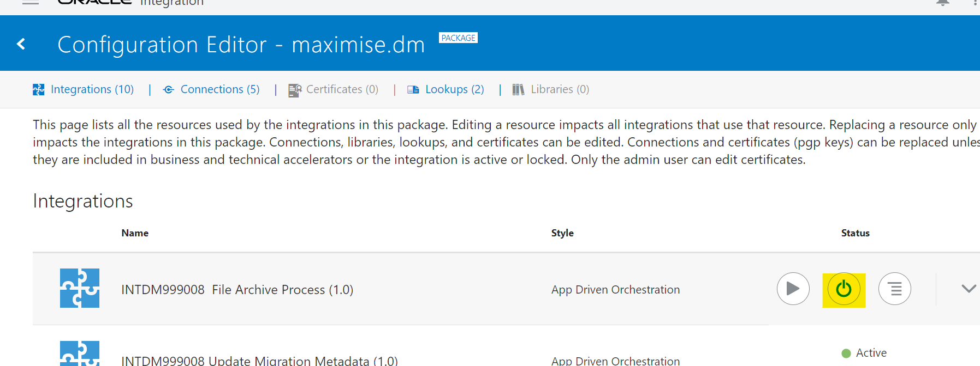

1. Check the Enable Tracing box and click on Activate

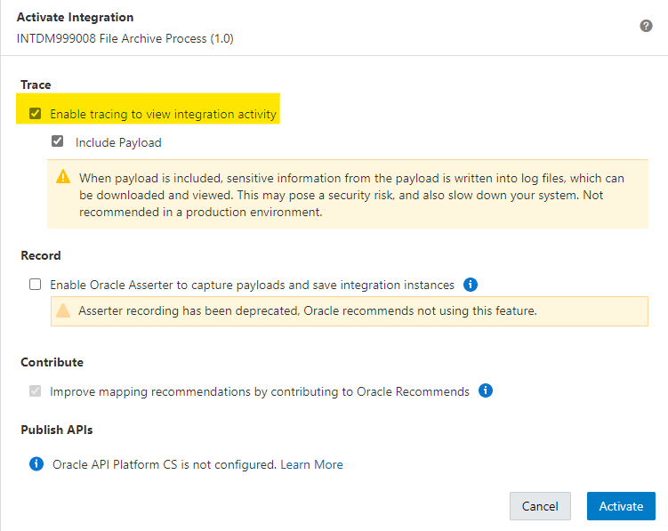

1. Once Integration status is Active, test the connections by running the integration

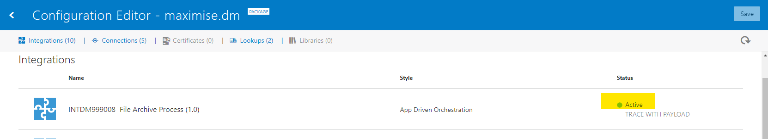

1. Schedule the below integrations
   1. INTDM999015 DM Write Load File to DB Server
   2. INTDM999017 Moves Load File from DB Server to FTP

#### Deactivate Integrations

To deactivate an integration,

1. Navigate to Integrations under the Packages > Configuration Editor > Integrations



1. Click on the Deactivate icon (see example below)



1. Integrations can be edited, once the status is Deactivated

## STEP 4: VBCS

### Pre-Requisite

* Maximise installation is complete and Core OIC Objects are installed
* Admin Access to Oracle Integration Cloud should be provided to the integration user.
* Downloaded the latest version of the **Maximise_Data_Migration-VBCS_1.0.zip** file from Gitlab (this file should be under the **Install/VBCS** folder)

### Installation

1. Login to the Integration server and navigate - Oracle Integration > Home > Visual Builder

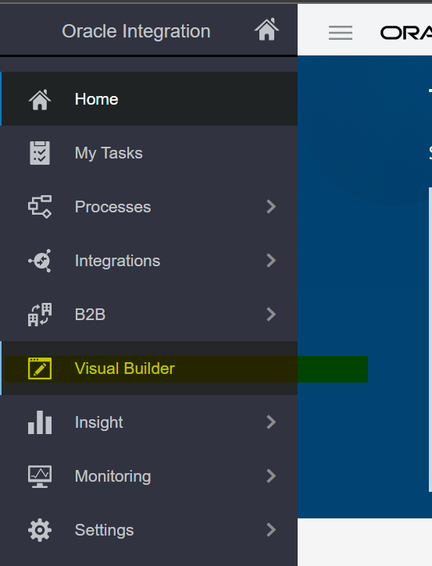

1. Click on **Import Application**

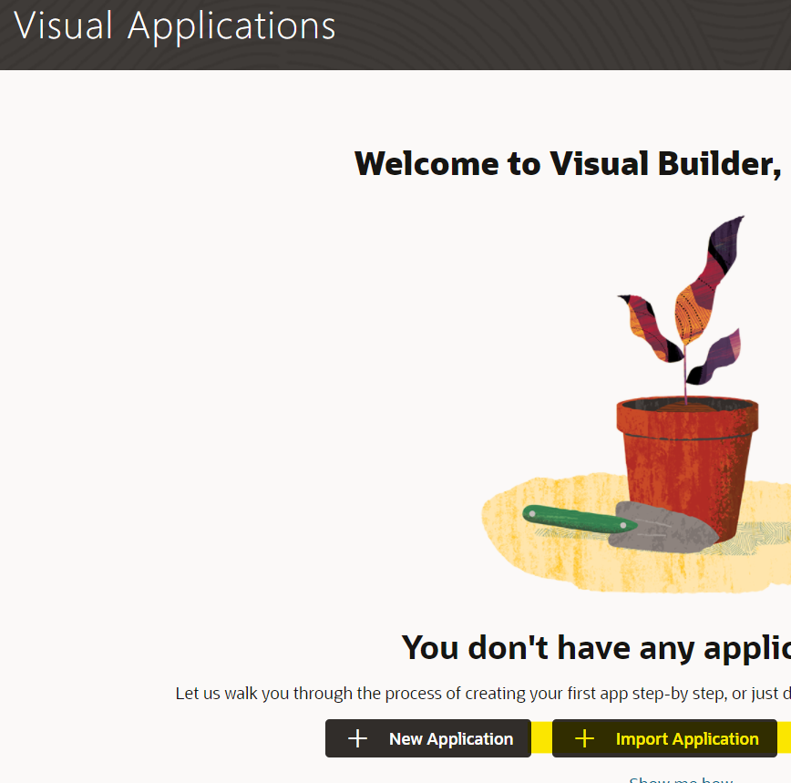

1. Select **Application from file** import option

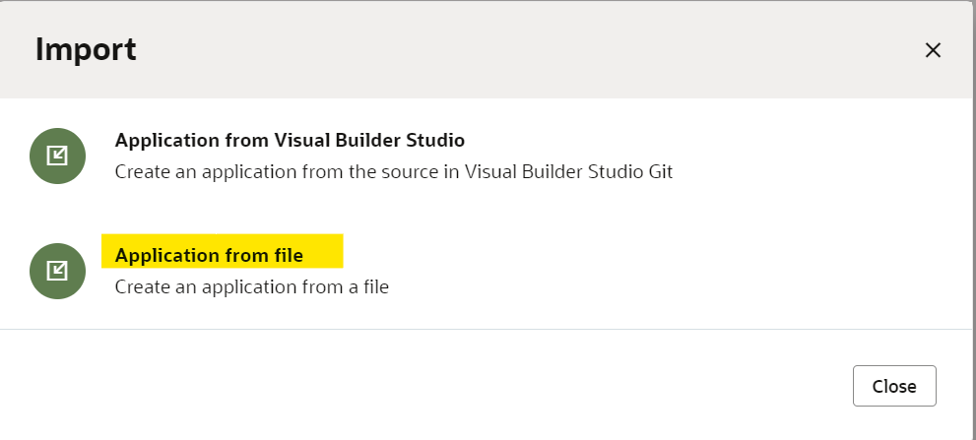

1. Drag and drop the zip file downloaded (covered under the VBCS Pre-Requisite section)

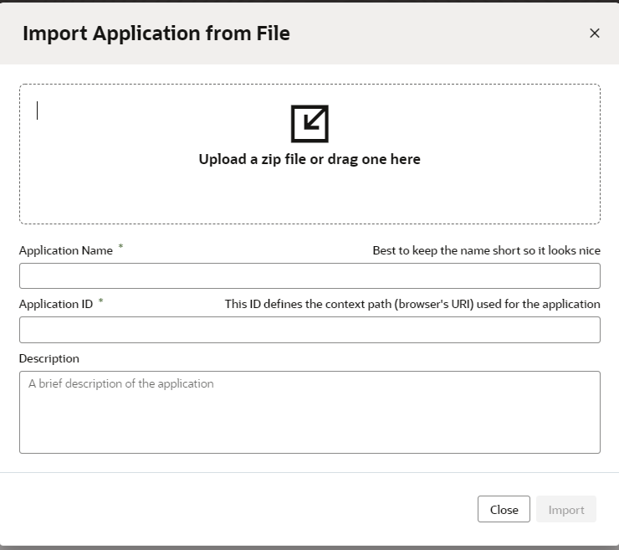

1. Enter the Application Name and Application ID

e.g., Application name: Maximise Data Migration

Application ID: 1234

1. Provide VBCS application access to the DM team



[**www.version1.com**](http://www.version1.com)

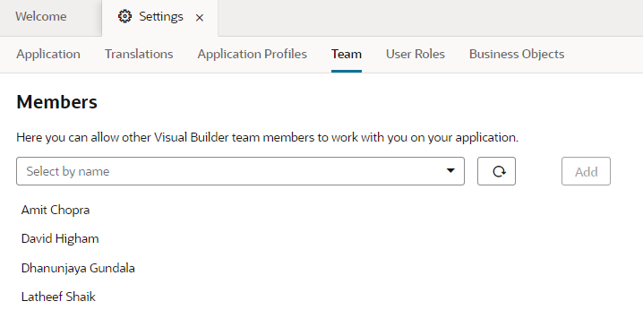

1. Installation is now complete.

## STEP 5: Validation Reports

### Pre-Requisite

* Maximise installation is complete, and Core Objects are installed

### Configuration

1. Run and Install validation tables of respective Business Entities in the Core Schema.
2. Import the Validation Package of each business entity in the folder **VALIDATION REPORTS under Install.**
3. Make entries of each validation table name, package name, and procedure name under VAL_TABLE_NAME, VAL_PACKAGE_NAME, and VAL_PROCEDURE_NAME columns in **xxmx_migration_metadata** against the respective sub-entity.

### Execution

1. To validate the extracted data of an entity we need to execute the validation procedure of it as below

**Exec Package.Procedure(‘APPLICATION_SUITE’, ‘APPLICATION’, ‘BUSINESS_ENTITY’);**

### Available Validations

| Business Entity | Sub Entity | Validations |
| --- | --- | --- |
|  |  |  |
| SUPPLIERS | SUPPLIERS | * Validate Supplier Records getting duplicated * Validate Supplier name getting duplicated * Validate Supplier TRN is duplicated * Validate Supplier Name having Junk / Invalid characters * Validate Suppliers when the Federal Reportable flag is Y/N |
| SUPPLIER_ADDRESSES | SUPPLIER_ADDRESSES | * Validate Supplier Address Records getting duplicated * Validate Supplier Name having Junk / Invalid characters |
| SUPPLIER_SITES | SUPPLIER_SITES | * Validate Supplier Site Name having Junk / Invalid characters * Validate Supplier Sites whose Remittance Advice Delivery Method is null however Remittance Email or Remittance Fax is not null * Validate Supplier Sites where Hold Reason cannot be null when the supplier has been applied any of the three 'Hold from Payment' holds * Validate Supplier Sites where Address Name is blank * Validate Supplier Sites where Pay Site Flag or Purchasing Site Flag is 'Y' and where RFQ Only Site Flag = 'Y' |
| SUPPLIER_THIRD_PARTY_RELS |
| SUPPLIER_CONTACT | SUPPLIER_CONTACTS | * Validate Supplier Contact with First Name null or Email Address null or Email address not having ‘@’ |
| SUPPLIER_CONT_ADDRS |
| SUPPLIER_SITE_ASSIGNS | SUPPLIER_SITE_ASSIGNS | * Validate Supplier Site match or not |
| SUPPLIER_BANK_ACCOUNTS | SUPPLIER_PAYEES | * Validate Supplier Payee * Validate Supplier Bank Name having Junk / Invalid characters |
| SUPPLIER_BANK_ACCOUNTS |
| SUPPLIER_PMT_INSTRS |
| PURCHASE_ORDERS | PO_HEADERS_STD | * Validate if PO is open but Vendor/Vendor Site is inactive * Validate if Buyer is an active employee * Validate Supplier Sites whose Remittance Advice Delivery Method is null however Remittance Email or Remittance Fax is not null * Validate if PO Header has at least one PO Line |
| PO_LINES_STD | * Validate if unit price value exceeds 10 decimal places * Validate if PO Line has at least one PO header * Validate if PO Line Line has at least one PO Line Location |
| PO_LINE_LOCATIONS_STD | * Validate if PO Line Location has at least one PO Line * Validate if PO Line Location has at least one PO Distribution * Validate if PO Line Quantity matches with PO Line Location Quantity * Validate if PO Line Amount matches with PO Line Location Amount |
| PO_DISTRIBUTIONS_STD | * Validate if Requestor is an active employee * Validate if Project is closed or not * Validate if Task is closed or not when Project is Open * Validate if PO Distribution has at least one PO Line Location * Validate if PO Line Location Quantity matches with PO Distribution Quantity * Validate if PO Line Location Amount matches with PO Distribution Amount |